PROJECT REPORT FOR

Foundations of Artificial Intelligence

AADU PULI AATAM

A PROJECT REPORT

Submitted by
2116240701313 – MITHULESH . J
2116240701315 – MITHUN RAJ .D


October, 2026

BONAFIDE CERTIFICATE

Certified that this project report “AADU PULI AATAM is the bonafide work of “MITHULESH.J & MITHUN RAJ.D” who carried out the project work under my supervision.

SIGNATURE OF THE FACULTY INCHARGE

Submitted for the Practical Examination held on

SIGNATURE OF THE INTERNAL EXAMINER

TABLE OF CONTENTS
CHAPTER NO. | TITLE | PAGE NO.
 | Abstract | 3
1 | Introduction | 5
2 | Literature Review | 7
2.1 | Traditional Board Games and Artificial Intelligence | 7
2.2 | Minimax Algorithm | 8
2.3 | Digital Traditional Games | 8
2.4 | Multiplayer Game Systems | 9
2.5 | Motivation for the Proposed System | 9
3 | Proposed System | 10
3.1 | System Workflow | 11
3.2 | Game Modes | 11
3.3 | AI Difficulty | 12
3.4 | Architecture Diagram | 13
4 | Modules Description | 14
4.1 | User Interface and Game Board Module | 14
4.2 | Game Logic Module | 15
4.3 | Minimax AI Module | 16
4.4 | Tactical Coach Module | 17
4.5 | Multiplayer Module | 17
4.6 | Scoreboard and History Module | 18
4.7 | Game Control Module | 18
5 | Implementation And Result | 19
5.1 | Experimental Setup | 19
5.2 | Results | 21
6 | Conclusion And Future Work | 23
6.1 | Conclusion | 23
6.2 | Future Work | 24
7 | Reference | 26

ABSTRACT

Aadu Puli Aatam, also known as Goat and Tiger, is a traditional Tamil strategy game in which three tigers compete against fifteen goats on a fixed game board. The game requires players to think strategically, plan movements, block opponents, and make tactical decisions. This project presents a web-based digital implementation of Aadu Puli Aatam that combines traditional gameplay with Artificial Intelligence.
The proposed system provides an interactive gaming environment where users can play as either goats or tigers against an AI opponent. The system uses the Minimax algorithm to enable the AI player to evaluate possible game moves and select suitable actions. Different AI difficulty levels are provided so that players can experience different levels of challenge.
The application also supports local two-player gameplay and online room-based gameplay. The local mode allows two players to play on the same device, while the online mode allows players to participate through a realtime game room. The system provides a live match status, turn countdown, legal move information, tactical recommendations, move history, undo functionality, sound control, and match statistics.
The main objective of the project is to preserve and modernize a traditional Tamil strategy game by providing an accessible digital platform. The project demonstrates how Artificial Intelligence, game algorithms, web technologies, and interactive user interfaces can be combined to create an engaging strategy game.
Keywords: Aadu Puli Aatam, Artificial Intelligence, Minimax Algorithm, Game Theory, Strategy Game, Tamil Traditional Game, Web Application, Multiplayer Game.

Chapter-1

INTRODUCTION

- Traditional games are an important part of cultural heritage and provide opportunities for strategic thinking and entertainment. Aadu Puli Aatam is a traditional Tamil board game involving three tigers and fifteen goats. The game is based on strategic movement, blocking, hunting, and positioning.
- In the traditional version, players must carefully plan their moves. The tiger player attempts to capture goats, while the goat player attempts to restrict the movement of the tigers by creating strategic blocks. Because both sides have different objectives, the game requires planning and decision-making.
- The objective of this project is to implement Aadu Puli Aatam as an interactive web application. The system allows users to select their preferred side and play against an Artificial Intelligence opponent. The AI uses the Minimax algorithm to evaluate possible moves and select an appropriate move based on the current game state.
The application provides two primary AI modes:
- Goats vs AI Tigers
- Tigers vs AI Goats
In addition to AI gameplay, the application provides Local 2 Player mode and Online Room mode. The local mode allows two players to play on the same device, while the online mode provides room-based multiplayer gameplay.

1. Traditional Game Board
The system digitally represents the Aadu Puli Aatam board using a 23-point grid.
2. AI Opponent
The system provides an AI opponent based on the Minimax decision-making algorithm.
3. Multiple Difficulty Levels
The AI provides Easy, Medium, and Hard difficulty options, with different tactical levels of gameplay.
4. Multiple Game Modes
Users can select AI gameplay, local two-player gameplay, or online gameplay.
5. Tactical Recommendation
The system provides tactical suggestions to help players understand possible strategic actions.
6. Live Match Status
The application displays the current turn, available moves, game state, and countdown timer.
7. Match Statistics
The system maintains information such as goats placed, goats captured, tiger count, wins, and streak information.
8. Move History
Players can view the sequence of moves performed during the current match.

9. Undo and Sound Controls
The interface provides undo functionality and sound control for a better gaming experience.
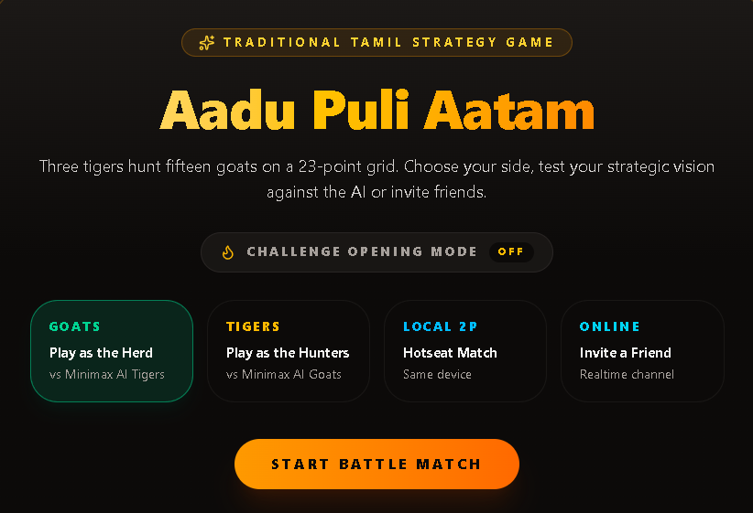
Fig 1.1 Home page

Chapter-2

LITERATURE REVIEW

2.1 Traditional Board Games and Artificial Intelligence
- Traditional board games provide a useful environment for studying Artificial Intelligence because they involve clearly defined states, actions, rules, and objectives. AI algorithms can analyze possible game states and select actions based on the expected outcome.
- Strategy games are particularly suitable for search algorithms because the AI can examine possible future moves before selecting its current action.
2.2 Minimax Algorithm
- The Minimax algorithm is a classical Artificial Intelligence algorithm used in two-player games. It works by considering the possible actions of both players and selecting a move that maximizes the AI player's expected advantage while assuming that the opponent will also choose a suitable move.
- In Aadu Puli Aatam, the game state consists of the positions of the three tigers, the positions of the goats, the current player's turn, and other game conditions. The AI can evaluate possible legal moves and select an appropriate action.
The general Minimax decision process can be represented as:
- Identify the current game state.
- Generate possible legal moves.
- Simulate possible future states.
- Evaluate the resulting states.
- Consider the opponent's possible response.
- Select the move with the most suitable evaluation.

2.3 Digital Traditional Games
Web-based implementations of traditional games can improve accessibility and help introduce cultural games to younger generations. Digital implementations also make it possible to add features such as AI opponents, multiplayer functionality, statistics, and interactive guidance.
2.4 Multiplayer Game Systems
Modern web applications can support both local and online multiplayer gameplay. Local multiplayer allows players to share a single device, while online multiplayer allows users to communicate game states through a realtime connection.
The proposed Aadu Puli Aatam application incorporates both approaches to provide different gameplay options.
2.5 Motivation for the Proposed System
Traditional Aadu Puli Aatam requires another player to participate in the game. A digital AI opponent can allow a single user to play without requiring another person. The addition of different AI difficulty levels also allows users to select an appropriate challenge level.
Therefore, the proposed system combines traditional gameplay rules with Artificial Intelligence and modern web-based interaction.
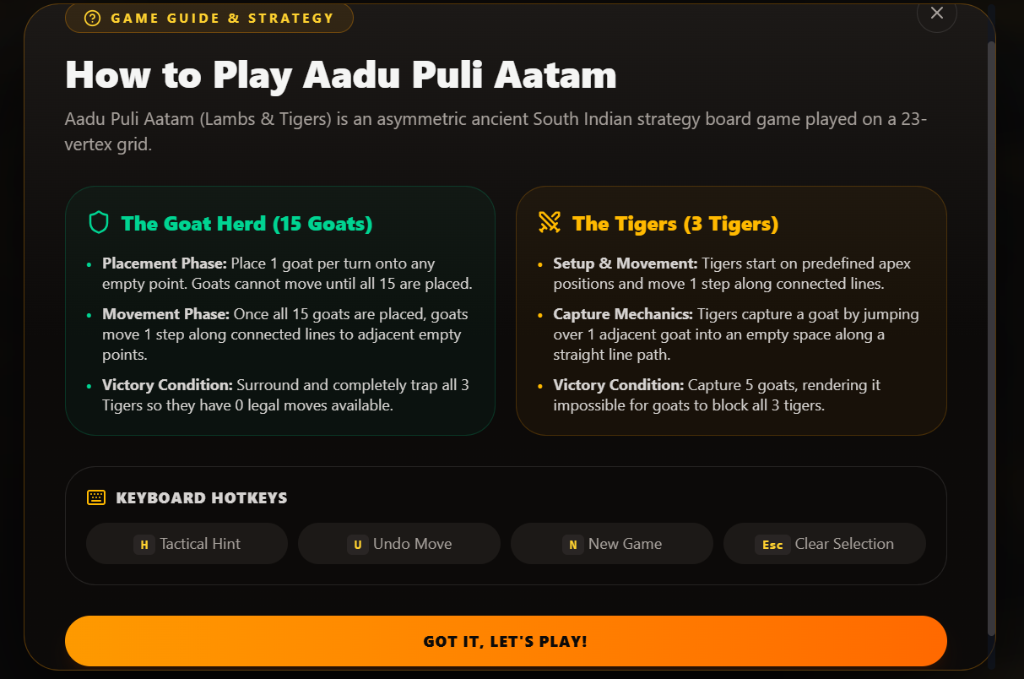Fig 2.1 Giude & Strategy

Chapter-3

PROPOSED SYSTEM

The proposed system is a web-based digital implementation of Aadu Puli Aatam. The system provides a graphical interface through which users can play the traditional strategy game against an AI opponent or another player.
The game consists of three tigers and fifteen goats placed on a 23-point game grid. Each player has a different objective.
The goat player attempts to position goats strategically and restrict tiger movement, while the tiger player attempts to move strategically and capture goats.
3.1 System Workflow
The general workflow of the system is:
- User opens the Aadu Puli Aatam application.
- User selects a game mode.
- User selects the playing side when applicable.
- The game initializes the board.
- The current player is displayed.
- Legal moves are calculated.
- The player performs a move.
- The game state is updated.
- If the opponent is an AI, the Minimax algorithm analyzes possible moves.
- The AI selects and performs a move.
- The system updates the scoreboard and move history.
- The process continues until a winning condition is reached.

3.2 Game Modes
Goats vs AI Tigers
The user controls the goats while the AI controls the three tigers.
Tigers vs AI Goats
The user controls the tigers while the AI controls the goats.
Local 2 Player
Two players can play on the same device using a hotseat-style gameplay mode.
Online Room
Players can create or join an online room and play through a realtime channel.
3.3 AI Difficulty
The system provides different AI difficulty levels:
- Easy – Casual gameplay
- Medium – Tactical gameplay
- Hard – Expert-level challenge
The difficulty selection allows the user to control the level of AI challenge.

3.4 ARCHITECTURE DIAGRAM

The system architecture consists of the following major components:
The user interacts with the graphical game interface. The game engine manages the board state and validates moves. When an AI opponent is selected, the Minimax component evaluates possible moves and selects an action. The multiplayer component handles local or online gameplay.

ARCHITECTURE DIAGRAM
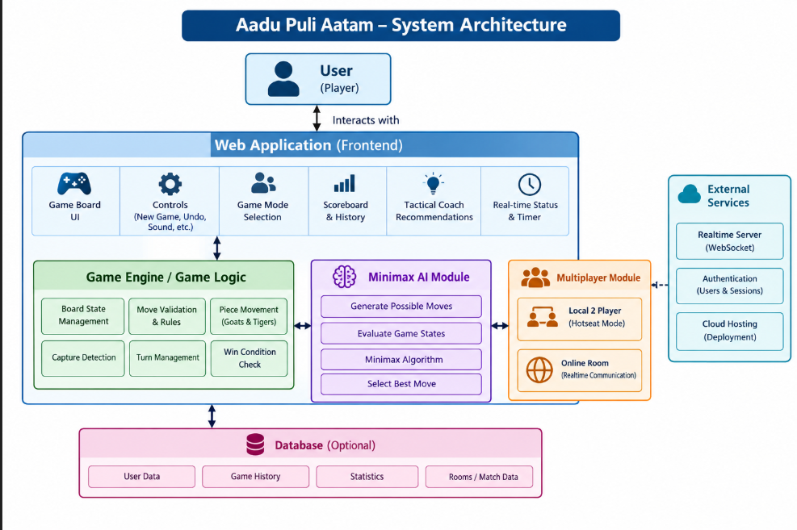
Figure 3.1: System Architecture

Chapter-4

MODULES DESCRIPTION

4.1 MODULE 1 – USER INTERFACE AND GAME BOARD MODULE
The User Interface and Game Board Module provides the main interaction area for the player.
The module displays the game board and represents the positions of the tigers and goats. It also provides controls for starting a new game, selecting game modes, changing AI difficulty, undoing moves, and controlling sound.
The module displays important game information including:
- Current turn
- Number of goats remaining
- Number of goats captured
- Number of tigers
- Available legal moves
- Turn countdown
- Match status
- Tactical recommendations
- Move history
The user can interact directly with the game board to place or move pieces.
Main Functions
- Display the game board.
- Display goats and tigers.
- Detect player interaction.
- Display current turn.
- Display legal moves.
- Display game status.
- Provide undo functionality.
- Provide sound controls.
4.2 MODULE 2 – GAME LOGIC MODULE
The Game Logic Module manages the rules and state of Aadu Puli Aatam.
The module maintains the positions of all pieces and determines whether a particular action is legal.
The main responsibilities include:
- Maintaining board state.
- Managing goat placement.
- Managing tiger movement.
- Detecting captures.
- Validating legal moves.
- Updating the current turn.
- Detecting winning conditions.
- Updating match statistics.
The game state changes after every valid action, and the updated state is provided to the user interface.

4.3 MODULE 3 – MINIMAX AI MODULE
The Minimax AI Module provides intelligent gameplay.
Minimax is a decision-making algorithm commonly used for two-player games. It evaluates possible future states and attempts to select a move that provides the best result for the AI while considering the opponent's response.
For each AI turn, the system:
- Receives the current game state.
- Generates possible legal moves.
- Evaluates possible resulting states.
- Considers opponent responses.
- Selects an appropriate move.
- Updates the game state.
4.4 MODULE 4 – TACTICAL COACH MODULE
The Tactical Coach provides strategic recommendations to the player.
For example, during the goat phase, the system can provide suggestions related to placing goats near important a https://apex-hunt-six.vercel.app/ of the board to create blocking structures against the tigers.
This feature makes the application useful not only as a game but also as a learning tool for understanding basic strategies.

4.5 MODULE 5 – MULTIPLAYER MODULE
The Multiplayer Module supports both local and online gameplay.
Local Multiplayer
The Local 2 Player mode allows two users to play on the same device. Players take turns making moves.
Online Multiplayer
The Online Room mode allows users to participate in a room-based match. A match code or room link can be used to allow another player to join the game.
The online mode uses a realtime communication mechanism to synchronize gameplay between players.

4.6 MODULE 6 – SCOREBOARD AND HISTORY MODULE
The Scoreboard and History Module displays information about the current and previous games.
The application provides:
- Goats placed
- Goats captured
- Tiger count
- Goat wins
- Tiger wins
- Winning streak
- Total games
- Move history
The Move Feed History records actions performed during the current match, allowing the player to review gameplay.

4.7 MODULE 7 – GAME CONTROL MODULE
The Game Control Module provides additional controls to improve the user experience.
The available controls include:
- New Game
- Tactical Hint
- Undo
- Sound On/Off
- Challenge Opening Rule
- AI Difficulty Selection
- Game Mode Selection
These controls allow users to customize the gameplay experience.
The module also provides session management features that allow debugging conversations to be stored locally in the browser. Users can search and resume previous debugging sessions and export complete sessions in Markdown format. These features make the coding environment more organized and allow users to review their previous debugging activities and learning progress.

Main functions:
    - Code writing and editing using Monaco Editor.
    - Code execution and error viewing.
    - AI persona selection.

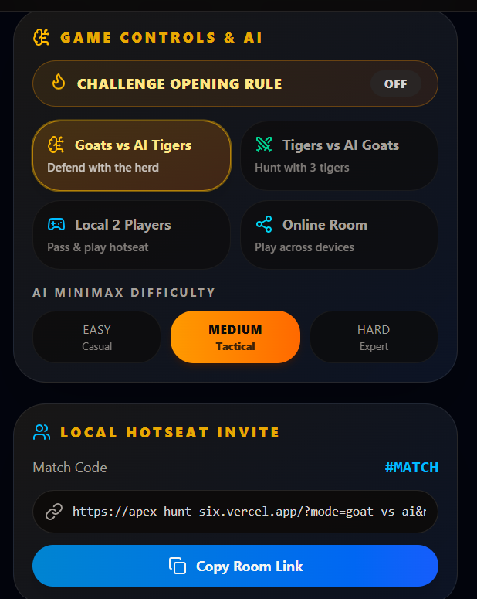
Fig 4.1 Game Control
Chapter-5
Implementation And Result

5.1 EXPERIMENTAL SETUP
The application was tested through the deployed web application.
The testing process included different gameplay configurations.
Test Case 1 – Goats vs AI Tigers
The user selects the goat side and plays against the AI-controlled tigers.
Expected result:
The user should be able to place goats and the AI should respond with tiger movements.
Test Case 2 – Tigers vs AI Goats
The user controls the tigers while the AI controls the goats.
Expected result:
The user should be able to move the tigers while the AI controls goat placement.
Test Case 3 – Local 2 Player
Two players use the same device.
Expected result:
The system alternates turns between the two players.
Test Case 4 – AI Difficulty
Different AI difficulty levels are selected.
Expected result:
The AI provides different levels of challenge.
Test Case 5 – Move History
Players perform multiple moves.
Expected result:
The moves are displayed in the Move Feed History.
Test Case 6 – Undo
The user selects the Undo option.
Expected result:
Test Case 7 – Online Room
A player creates an online room and shares the room information.
Expected result:
Another player can join the room and participate in the match.

5.2 RESULTS
The implemented system successfully provides an interactive digital version of Aadu Puli Aatam.
The application provides:
- A 23-point game board.
- Three tiger pieces.
- Fifteen goat pieces.
- AI-controlled opponents.
- Minimax-based gameplay.
- Multiple AI difficulty levels.
- Goat and tiger gameplay modes.
- Local two-player gameplay.
- Online room functionality.
- Live match status.
- Turn countdown.
- Legal move information.
- Tactical recommendations.
- Scoreboard.
- Move history.
- Undo functionality.
- Sound control.
- New game functionality.
The deployed application provides a unified interface where users can select their preferred game mode and play the traditional game digitally.
The system demonstrates that a traditional strategy game can be combined with Artificial Intelligence to create an interactive and educational web-based gaming experience.

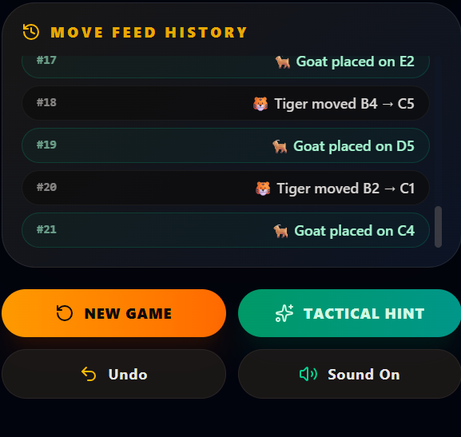
Fig 5.1.1 History of Move

Figure 5.1.2 -Login Page

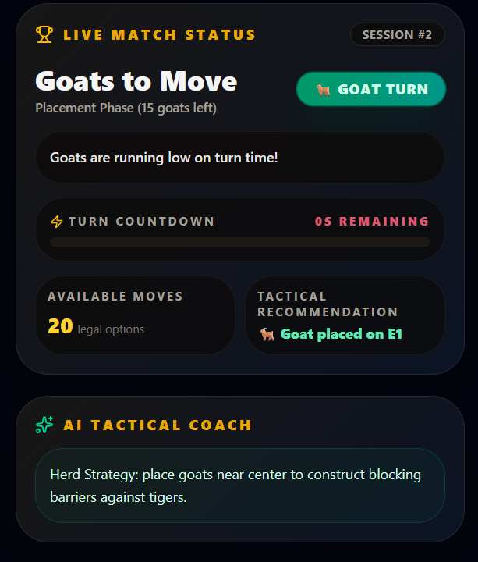
Fig 5.1.3 Live Status

RESULTS

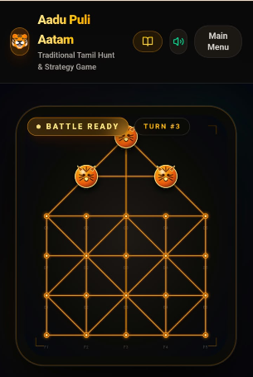

Figure 5.2.1 Gamepage

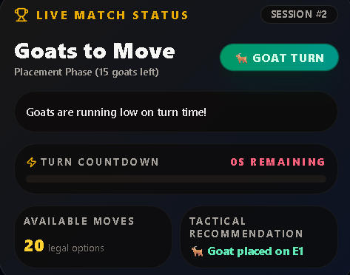

Figure 5.2.2 Match Status

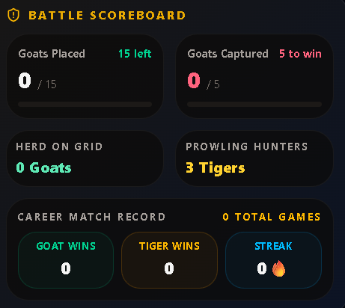

Figure 5.2.3 Scoreboard

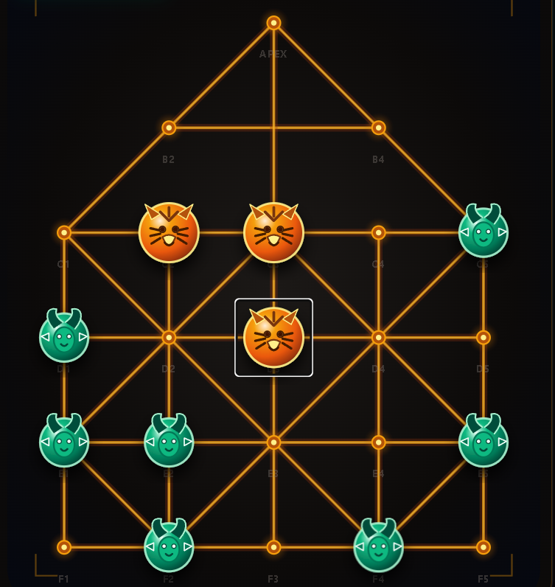
Figure 5.2.4 using Algorithm

Chapter-6

CONCLUSION AND FUTURE WORK
- Aadu Puli Aatam is a web-based implementation of the traditional Tamil Goat and Tiger strategy game. The project combines traditional gameplay rules with Artificial Intelligence and modern web-based interaction.
- The system allows users to play as either goats or tigers against an AI opponent. The implementation of the Minimax algorithm provides the AI with the ability to evaluate possible game moves and make strategic decisions.
- The application also supports local two-player and online room-based gameplay. Features such as AI difficulty levels, tactical recommendations, live match status, legal move information, move history, scoreboard, undo, and sound controls improve the overall gaming experience.
- The project demonstrates the practical application of Artificial Intelligence and game-search algorithms in a traditional board game. It also provides a digital platform for experiencing and learning about Aadu Puli Aatam.
- Overall, the system combines cultural heritage, Artificial Intelligence, strategy, and web technology into a single interactive application.

6.2 FUTURE WORK
- The project can be enhanced in several ways in the future.

1. Advanced AI
- More advanced game-playing algorithms and optimized search techniques can be incorporated to improve AI decision-making.

2. Improved Difficulty Levels
- Additional AI levels can be introduced with more sophisticated evaluation strategies.

3. Mobile Application
- The web application can be converted into a dedicated Android or iOS application.

4. Enhanced Online Multiplayer
- The online mode can be extended with matchmaking, player invitations, player profiles, and improved realtime synchronization.

5. Global Leaderboard
- A leaderboard system can be introduced to maintain player rankings and achievements.

6. Player Statistics
- Detailed statistics such as win percentage, average game duration, captures, and gameplay history can be added.

7. Tutorial Mode
- A dedicated tutorial can explain the rules, movements, strategies, and winning conditions of Aadu Puli Aatam.

8. Multiple Traditional Games
- The same platform can be expanded to include other traditional Tamil and Indian board games.

9. Improved Tactical Coach
- The tactical recommendation system can be enhanced to provide more detailed explanations of why a particular move is strategically useful.

10. Cultural Information
- Information about the history and cultural significance of Aadu Puli Aatam can be incorporated into the application to improve awareness of traditional games.

REFERENCES
- Russell, S. and Norvig, P., Artificial Intelligence: A Modern Approach, 4th Edition, Pearson.
- Hart, P. E., Nilsson, N. J. and Raphael, B., “A Formal Basis for the Heuristic Determination of Minimum Cost Paths,” IEEE Transactions on Systems Science and Cybernetics, 1968.
- Aadu Puli Aatam – Traditional Tamil Hunt & Strategy Game, Project Web Application, 2026.
- Minimax Algorithm – Classical Game-Playing Artificial Intelligence Technique.
- React Documentation, Meta Open Source.
- JavaScript Documentation, MDN Web Docs.
- Web application development and realtime multiplayer communication documentation.
- Game AI and Search Algorithm concepts related to two-player strategy games.
- Traditional Tamil Games and Cultural Heritage references related to Aadu Puli Aatam.
- Game theory and Artificial Intelligence literature related to adversarial search.

